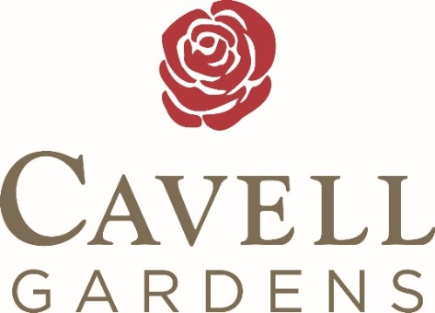


_____________ ___________
Pre-order before 10am at reception

ALWAYS AVAILABLE MENU
*VEGETARIAN OPTION June 1st – June 15th*

THREE PEROGIES & ROASTED GOLDEN BEETS w/ SOUR CREAM

SANDWICHES:
HAM, TURKEY HAM, TUNA, VEGETARIAN, EGG SALAD
or
DENVER OMELETTE
or
COTTAGE CHEESE & FRESH FRUIT PLATE

ALWAYS AVAILABLE DINNER
SOUP OF THE DAY w/DINNER ROLL. TOFU STEAK. BAKED CHICKEN. BAKED FISH. MASHED POTATO. RICE or GLUTEN FREE/VEGETARIAN PASTA w/ PRIMAVERA SAUCE



